 | Course Name: Advanced Web Technology | EXPERIMENT NO. 10
 | Course Code: 20CP314P  Faculty: Komal Singh | Branch: CSE
 | Course Code: 20CP314P  Faculty: Komal Singh | Semester: VI
Submitted by: Harsh Shah
Roll no: 21BCP359

Objective: Implement a web-app using Django framework
- Design a ‘Hello World’ Web-application using Django framework
views.py
from django.shortcuts import render

# Create your views here.
from django.http import HttpResponse

def hello_world(request):
return HttpResponse("Hello World!")

urls.py
"""
URL configuration for Lab_10 project.
The `urlpatterns` list routes URLs to views. For more information please see:
https://docs.djangoproject.com/en/4.2/topics/http/urls/
Examples:
Function views
1. Add an import: from my_app import views
2. Add a URL to urlpatterns: path('', views.home, name='home')
Class-based views
1. Add an import: from other_app.views import Home
2. Add a URL to urlpatterns: path('', Home.as_view(), name='home')
Including another URLconf
1. Import the include() function: from django.urls import include, path
2. Add a URL to urlpatterns: path('blog/', include('blog.urls'))
"""
from django.urls import path
from hello_world_app import views

urlpatterns = [
path('hello/', views.hello_world, name='hello_world'),
]
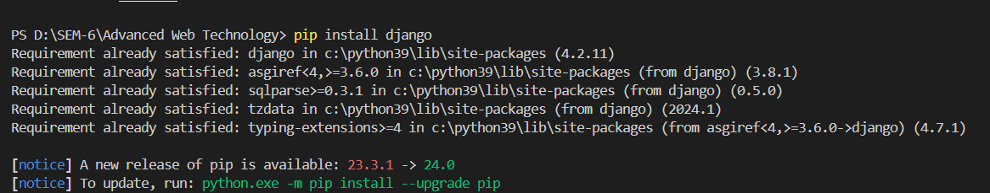
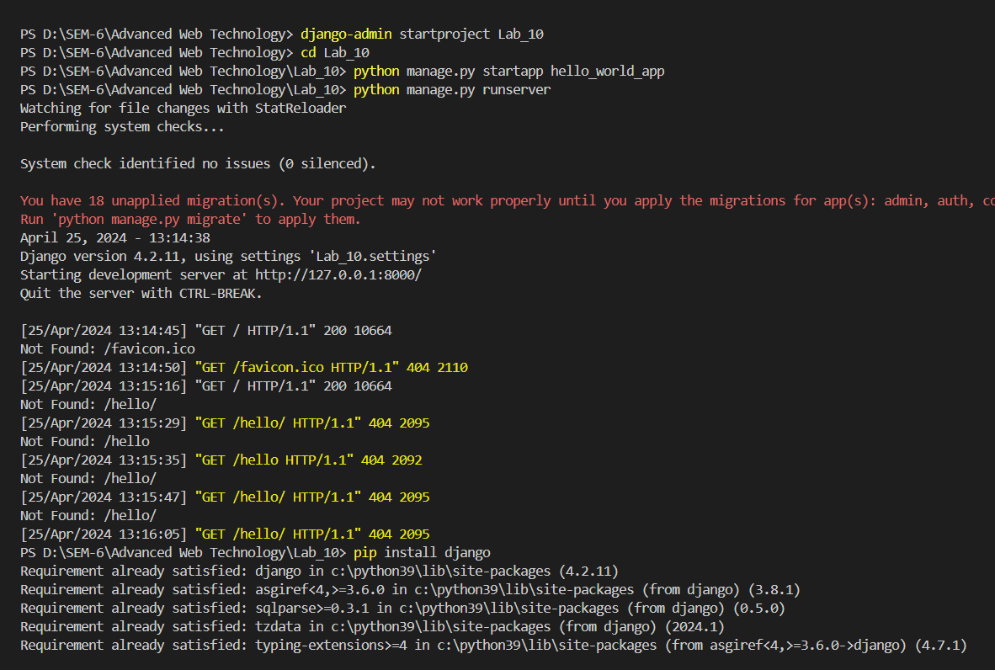
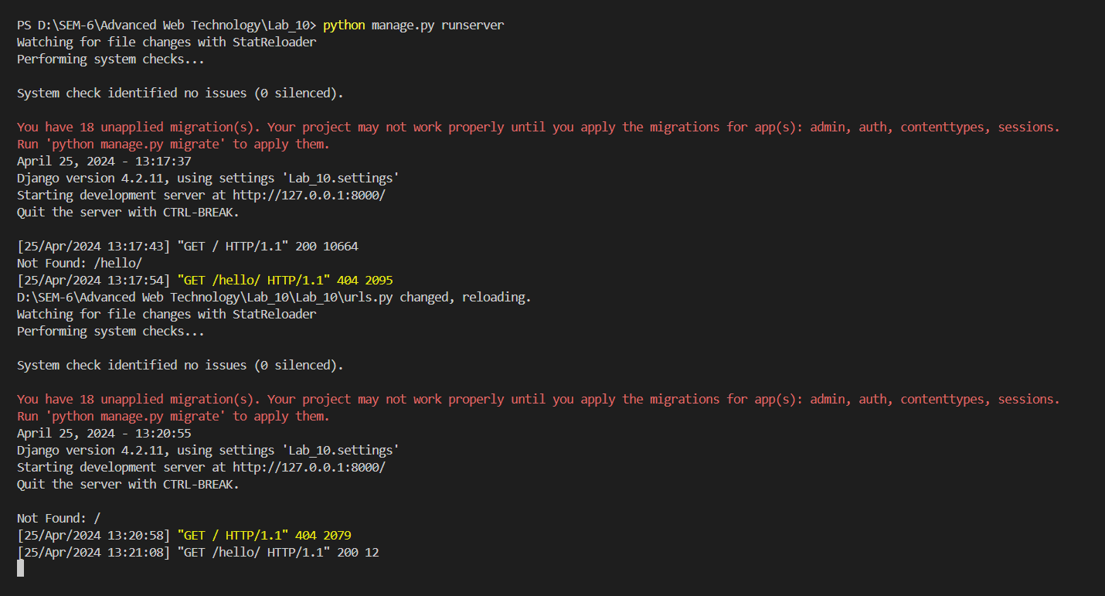
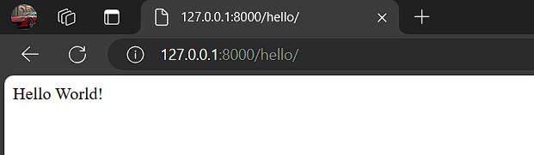

- Perform CRUD commands in a designed model using the default SQLite database extension in Django.
models.py
from django.db import models

class MyModel(models.Model):
name = models.CharField(max_length=100)
description = models.TextField()

class Meta:
app_label = 'hello_world_app'

settings.py
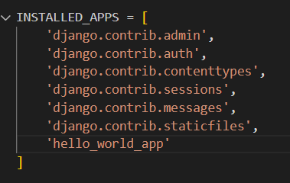
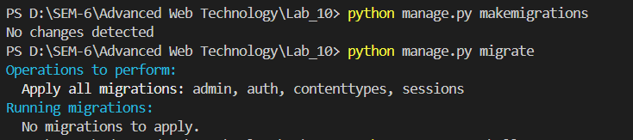
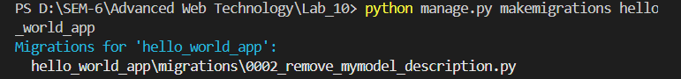
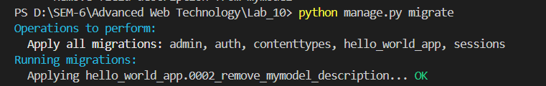
Output:
View SQL
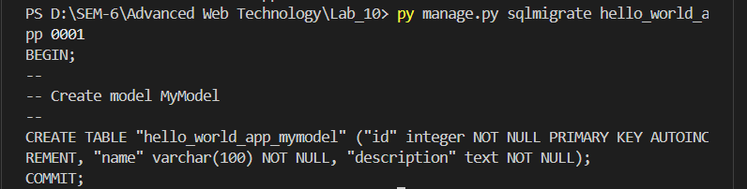
Add Records
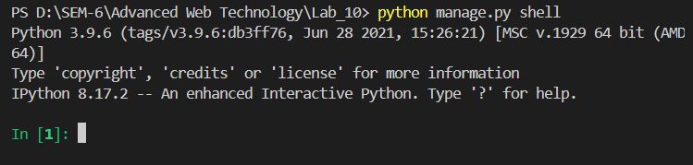
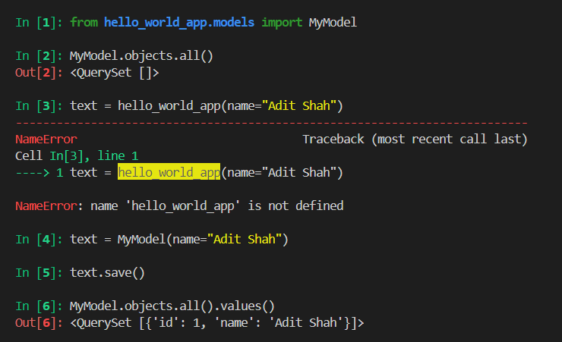
Update Records
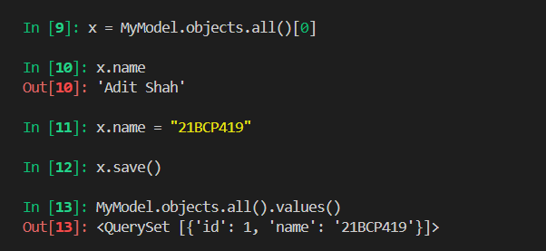
Delete Records
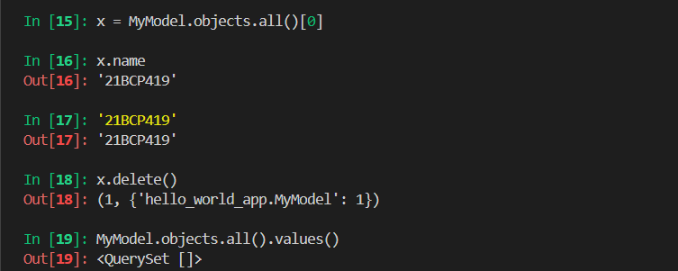

- Connect your Django web-application to PostgreSQL database and perform CRUD commands.
settings.py
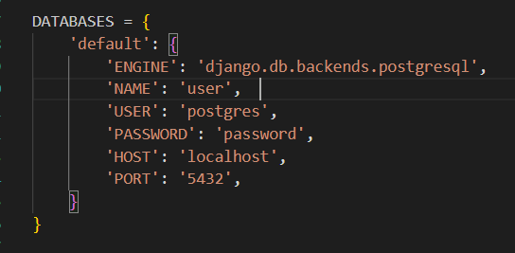

Views.py
from django.shortcuts import render, redirect
from .models import Item

def index(request):
items = Item.objects.all()
return render(request, 'index.html', {'items': items})

def create(request):
if request.method == 'POST':
name = request.POST.get('name')
description = request.POST.get('description')
Item.objects.create(name=name, description=description)
return redirect('index')
return render(request, 'create.html')

def update(request, item_id):
item = Item.objects.get(id=item_id)
if request.method == 'POST':
item.name = request.POST.get('name')
item.description = request.POST.get('description')
item.save()
return redirect('index')
return render(request, 'update.html', {'item': item})

def delete(request, item_id):
item = Item.objects.get(id=item_id)
item.delete()
return redirect('index')

urls.py
from django.urls import path
from . import views

urlpatterns = [
path('', views.index, name='index'),
path('create/', views.create, name='create'),
path('update/<int:item_id>/', views.update, name='update'),
path('delete/<int:item_id>/', views.delete, name='delete'),
]

Create.html
<h1>Create Item</h1>
<form method="post">
{% csrf_token %}
<label for="name">Name:</label>
<input type="text" name="name" required>
<br>
<label for="description">Description:</label>
<textarea name="description" required></textarea>
<br>
<input type="submit" value="Create">
</form>
Index.html
<h1>Items</h1>
<ul>
{% for item in items %}
<li>{{ item.name }} - {{ item.description }}</li>
{% endfor %}
</ul>
<a href="{% url 'create' %}">Create Item</a>

Update.html
<h1>Update Item</h1>
<form method="post">
{% csrf_token %}
<label for="name">Name:</label>
<input type="text" name="name" value="{{ item.name }}" required>
<br>
<label for="description">Description:</label>
<textarea name="description" required>{{ item.description }}</textarea>
<br>
<input type="submit" value="Update">
</form>

Output
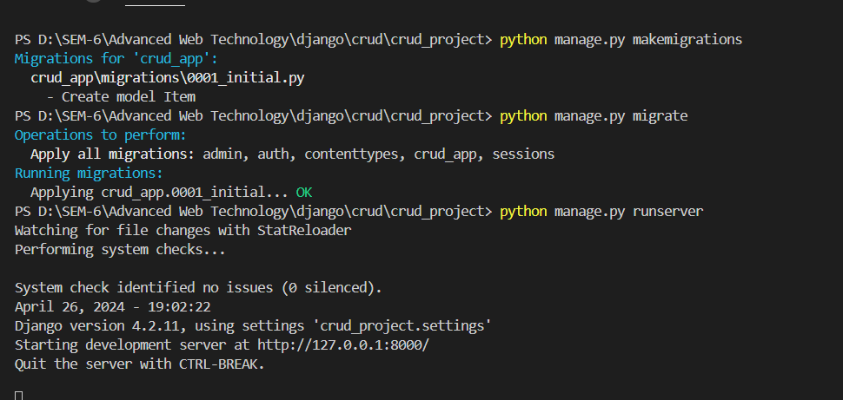
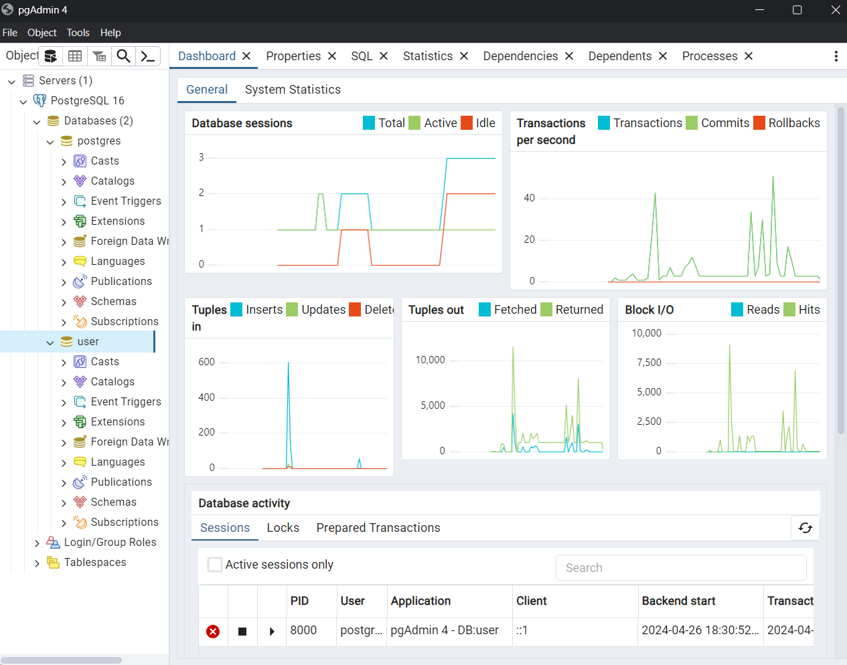
Output:
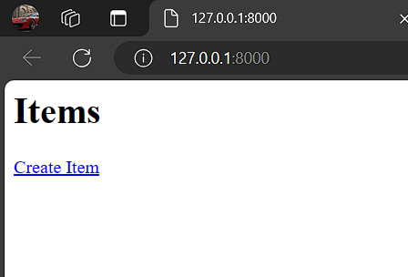

Add Records
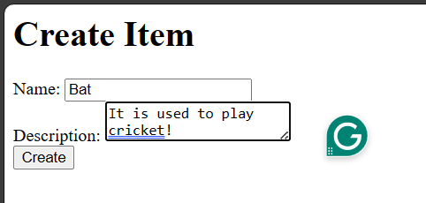
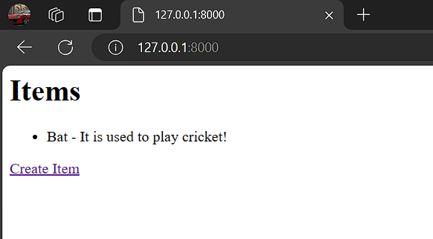
Update Records
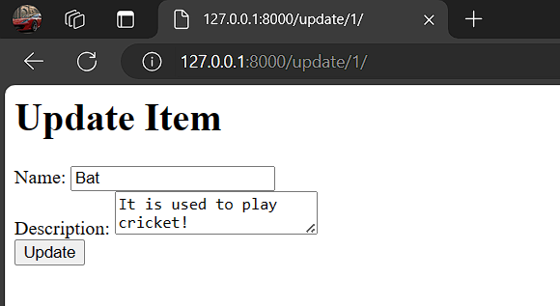
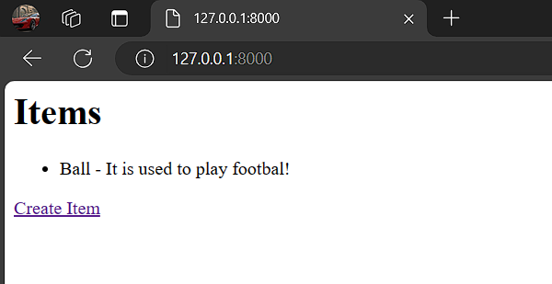

Delete Records
